DEVOPS ASSIGNMENT :-

1.Git Stash:- To save the uncommitted changes for later usage, you can use the git stash command. This command saves your local modifications away and reverts the working directory to match the head commit, so it will give you clean working directory.

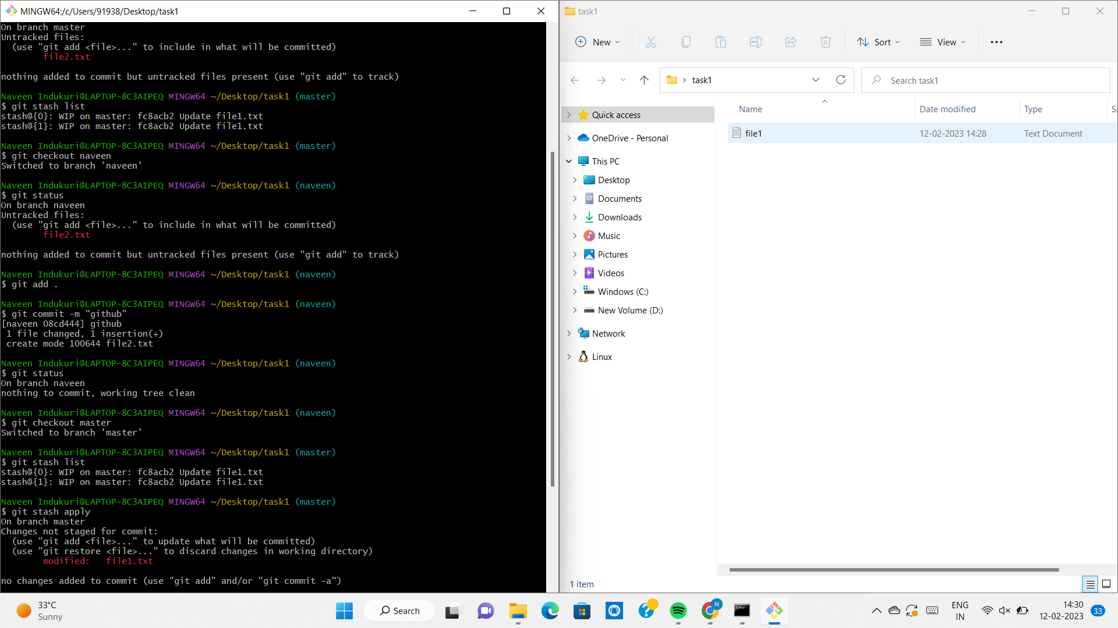

2.1 Git Fetch :-Git Fetch is the command that tells the local repository that there are changes available in the remote repository without bringing the changes into the local repository.

2.2 Git Merge :-Git Merge is a command used in Git to move the changes in branch to another. Usually, the new features are developed in the dev branch and merged into the master branch after finishing the development. All the changes in the dev branch is added to the master branch on the merge. but the dev branch will be unaffected.

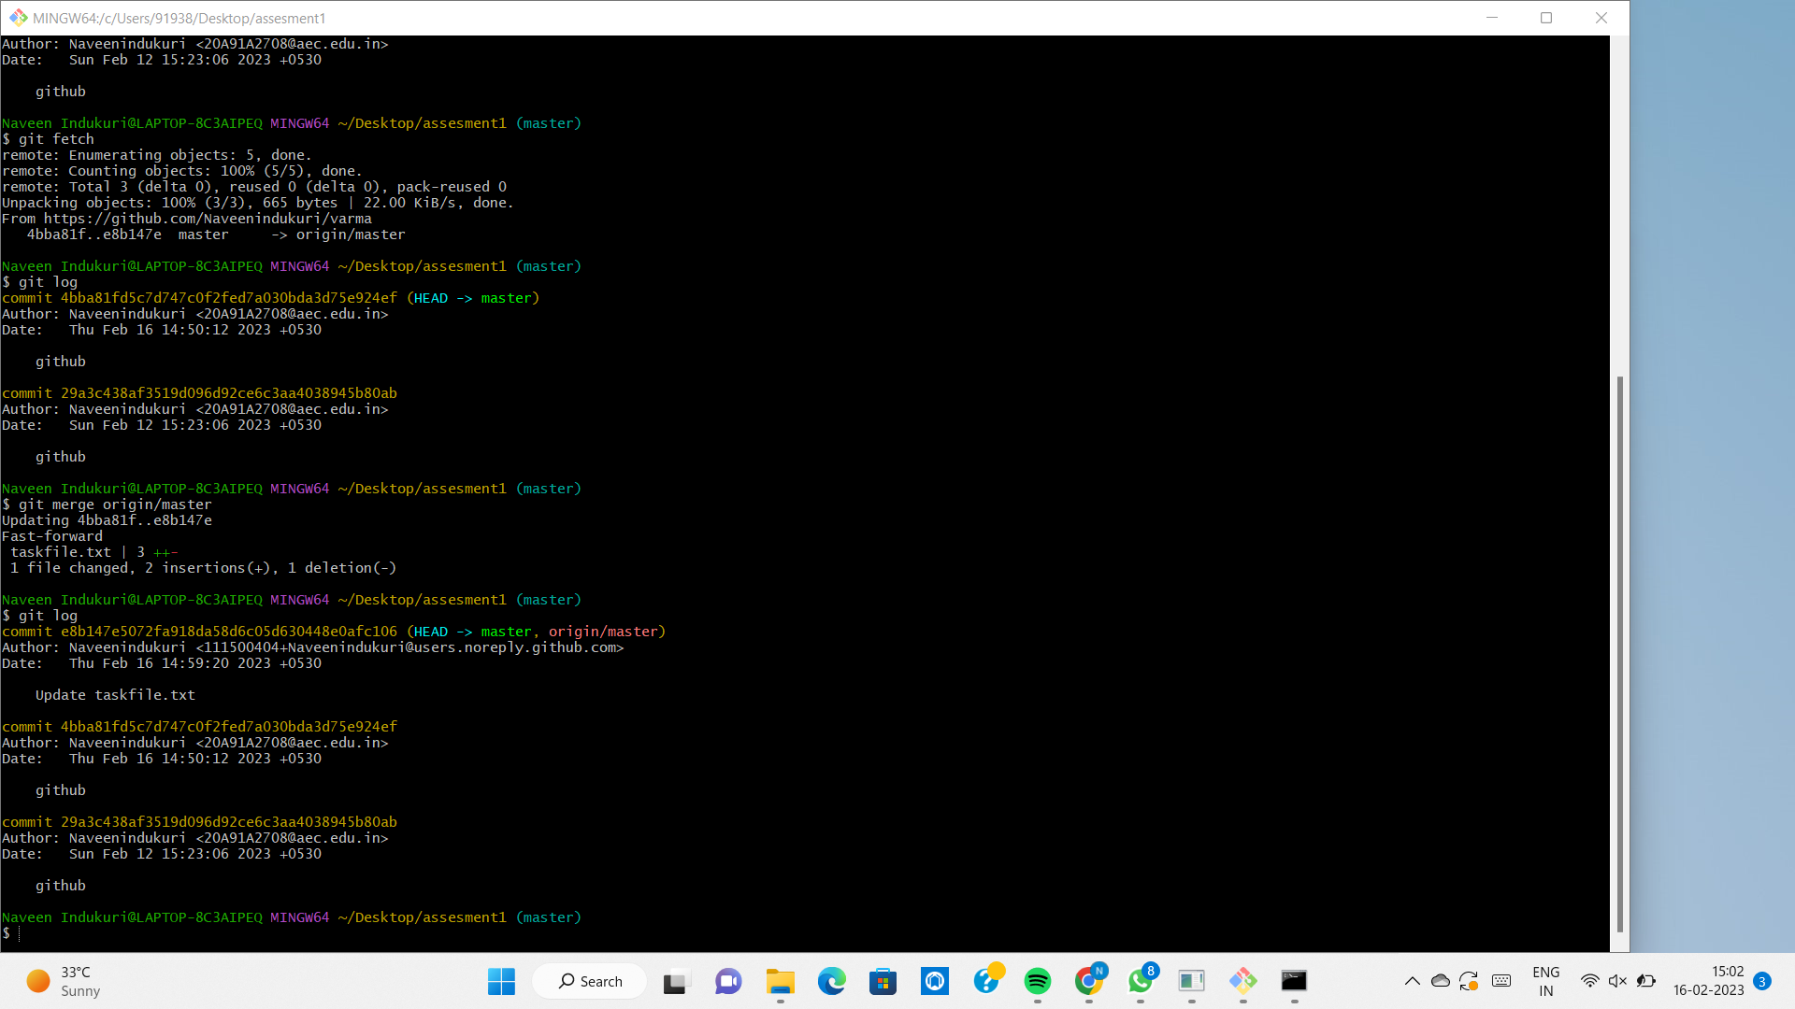

3. Difference btw git fetch & git pull :-

3.1 Git Fetch :-Git fetch commands gives the information of a new change from a remote repository without merging into the current branch. Repository data is updated in the git directory.

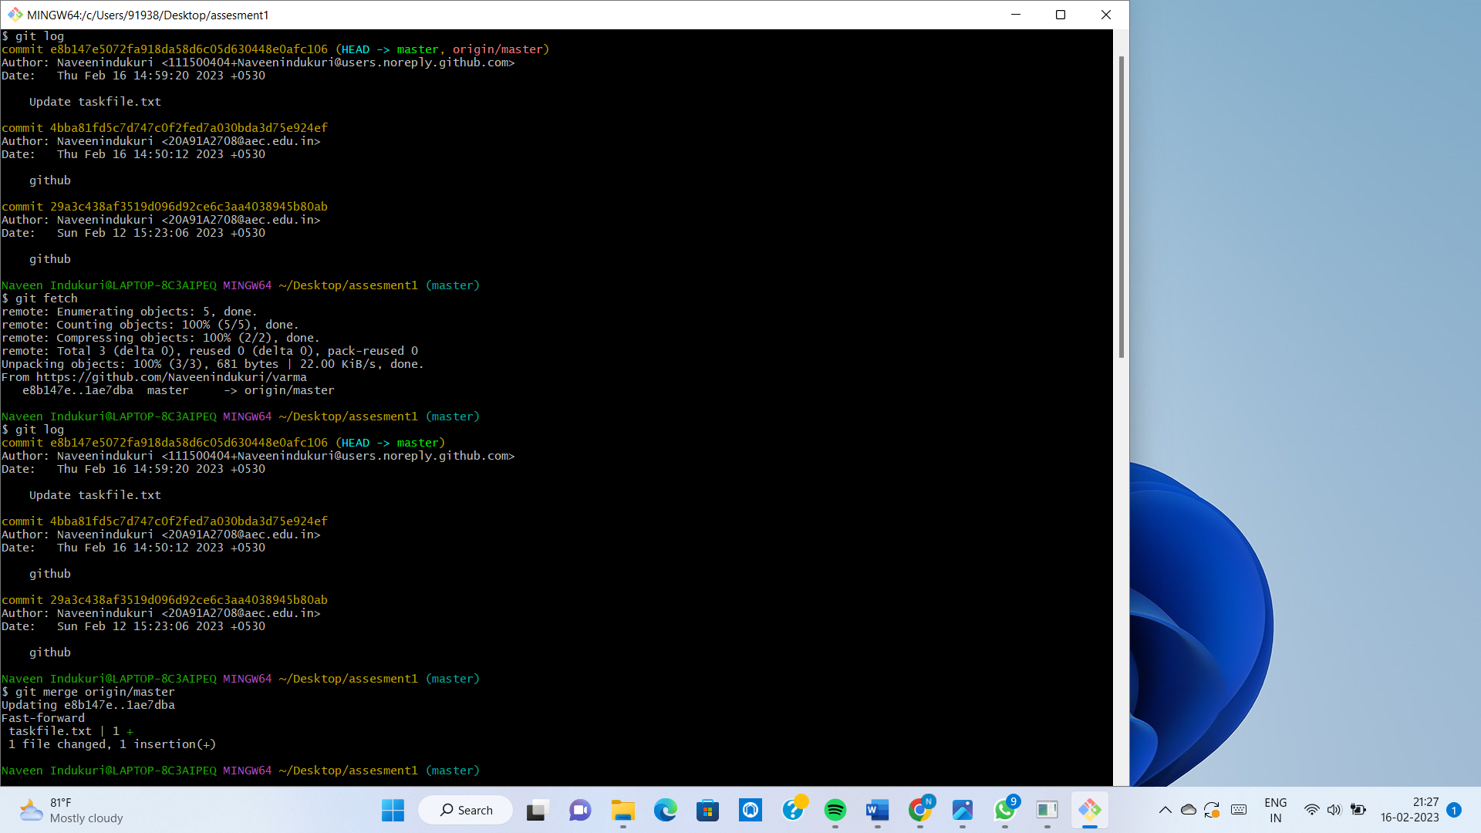

3.2 Git Pull :-Git pull brings the copy of all the changes from a remote repository and merges them into the current branch. The local repository is updated directly.

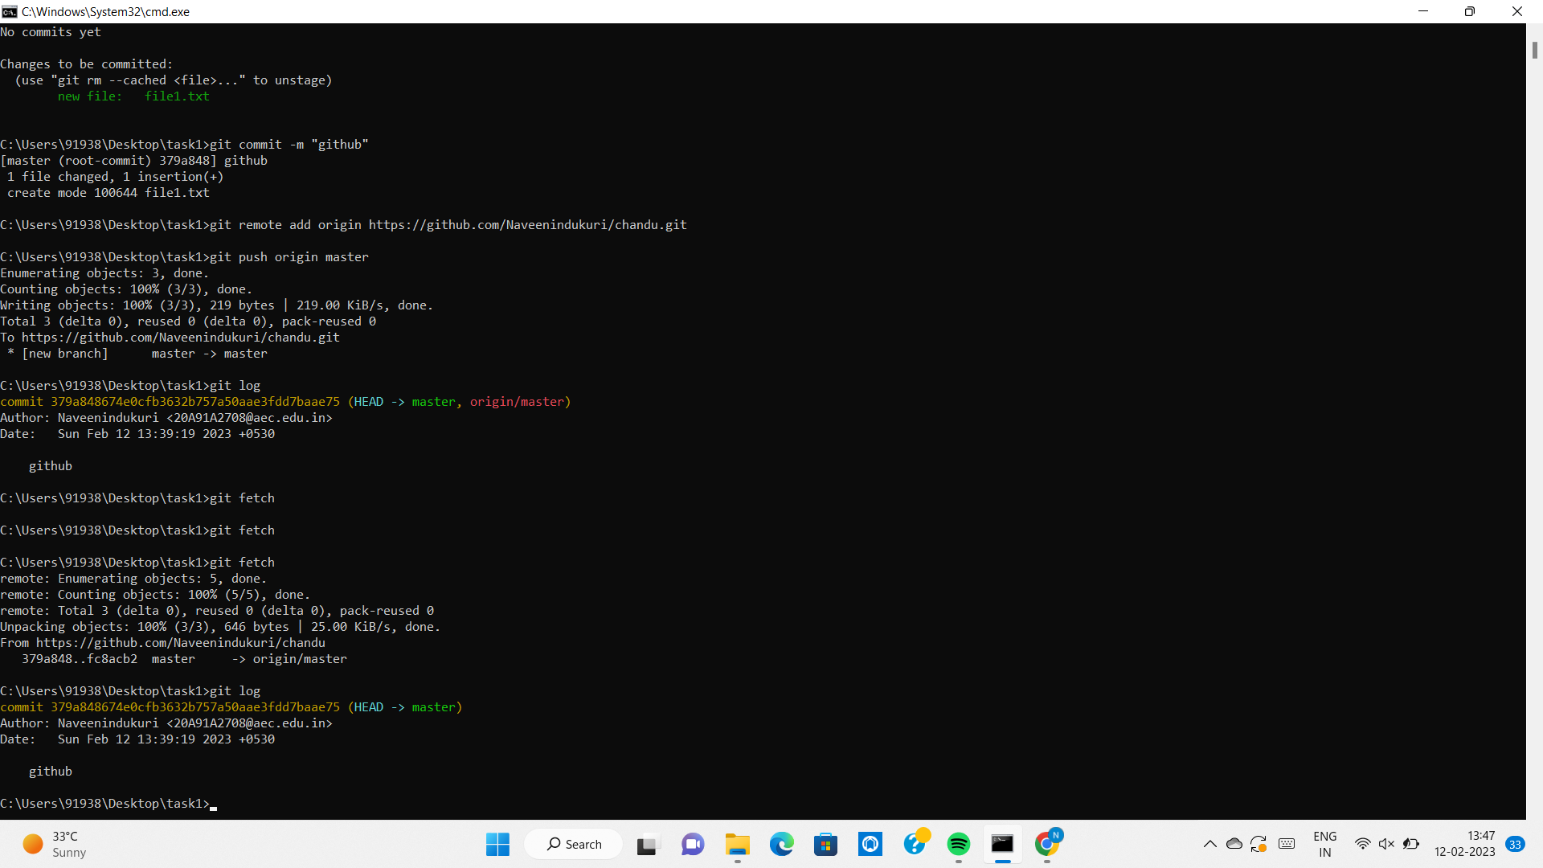

4.1 awk command :- Awk is mostly used for pattern scanning and processing. It searches one or more files to see if they contain lines that matches with the specified patterns and then perform the associated actions.

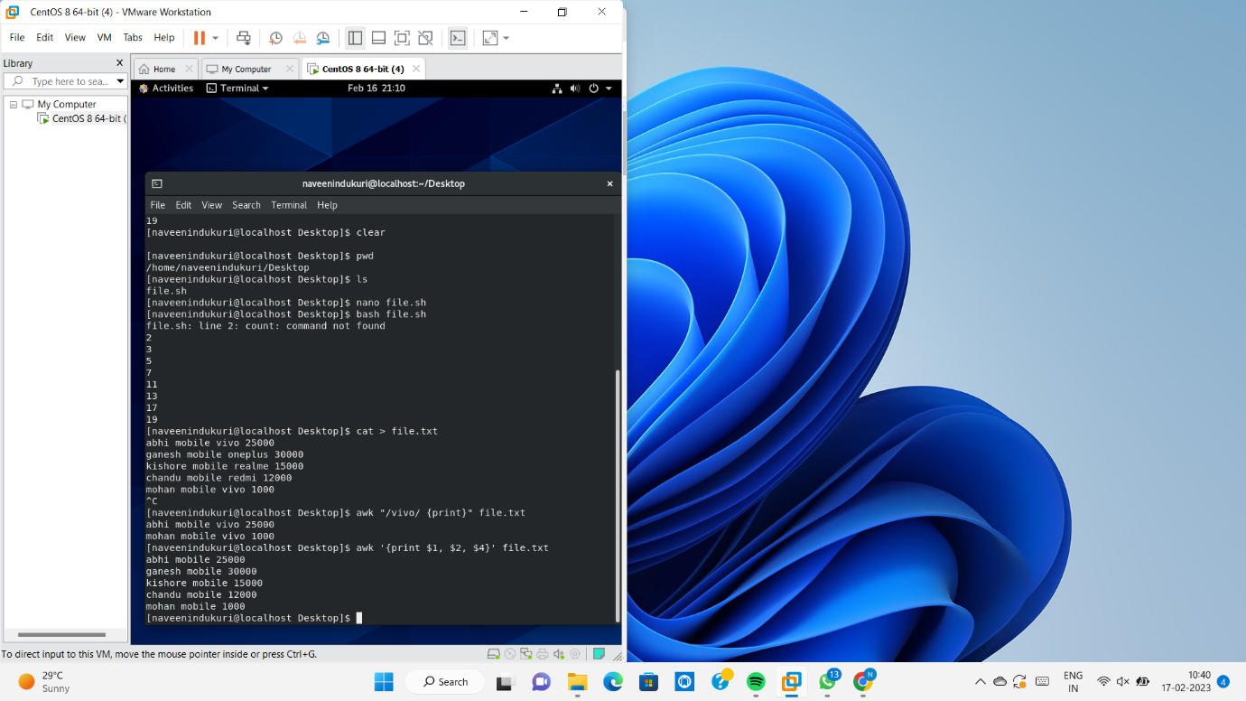

4.2 Prime numbers range 1 to 20 :-

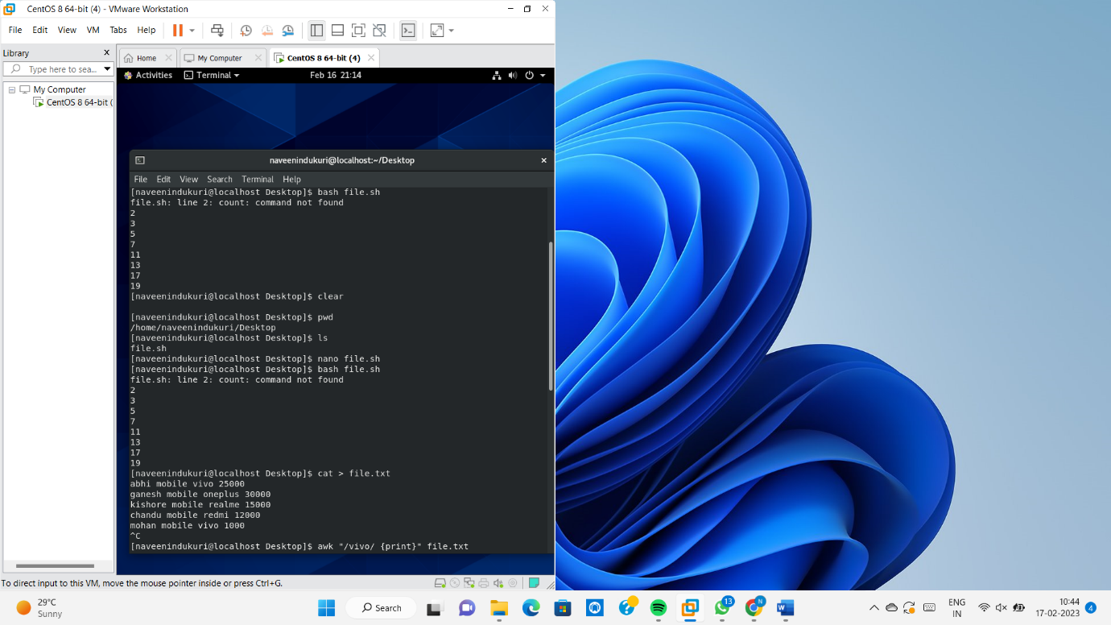

4.3 Commands History :-

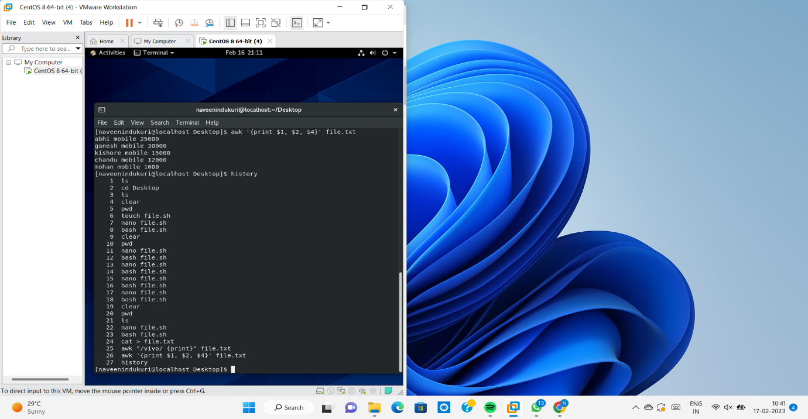

5. Containerization :-Containerization is a type of virtualization in which all the components of an application are bundled into a single container image and can be run in isolated user space on the same shared operating system.

